Monday 1st December 2025

Dear Parent/Carer

This year’s Christmas dinner will be on Wednesday 17th December.

Please indicate your choices below and return your slip by Friday 5th December. If we do not receive a reply, we will assume that a packed lunch is being provided on the day.

Yours sincerely,

Kind regards

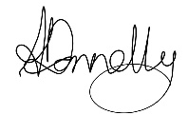

Andrea Donnelly
Executive Headteacher
Cleeve Prior Primary School

---------------------------------------------------------------------------------------------------------------------------

CHRISTMAS LUNCH – THURSDAY 17th DECEMBER
Name of child(ren) ...................................................................
□ I would like my child(ren) to have a traditional Christmas dinner, followed by Christmas Sparkle Cake,
and I enclose £3.00 for each dinner ordered
□ I would like my child(ren) to have a vegetarian option and I enclose £3.00 for each dinner ordered
□ No I will be providing my child(ren) with a packed lunch

Signature: ........................................................................

