Cleeve Prior CE Primary School
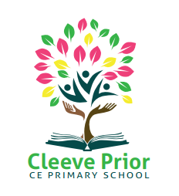
Policy for PSHE (Personal, Social, Health, Economic Education) - including RSE (Relationships and Sex Education)

Introduction
This policy has due regard to statutory legislation, including, but not limited to, the following: - DfE ‘Statutory framework for the early years foundation stage’ 2021 – DfE ‘Relationships Education, Relationships and Sex Education (RSE) Health Education Statutory guidance’ 2019 Education Act 2002
All schools must:
• Provide a curriculum that is broadly based, balanced and meets the needs of all pupils.
• Promotes the spiritual, moral, cultural, mental and physical development of pupils at the school and of society,
• Prepare pupils at the school for the opportunities, responsibilities and experiences of later life.
An amendment to the Children and Social Work Act 2017 made Relationships and Health Education at primary; and Relationships, Sex, and Health Education at secondary, statutory subjects.
At Cleeve Prior CE Primary School, the My Happy Mind and Heart Smart Programme we use covers all aspects of Relationships, Sex and Health Education (RSHE) within the context of a full PSHE programme in an age-appropriate way. Should changes to these curriculum areas occur in the future, My Happy Mind and Heart Smart will provide its schools with materials to ensure all statutory duties are fulfilled.
This PSHE policy is also informed by DfE guidance on Relationships, Sex and Health Education (as above), preventing and tackling bullying (Preventing and tackling bullying: Advice for Headteachers, staff and governing bodies, July 2013, updated 2017); drug and alcohol education (DfE and ACPO drug advice for schools: Advice for local authorities, Headteachers, school staff and governing bodies, September 2012); safeguarding (Working Together to Safeguard Children: A guide to inter-agency working to safeguard and promote the welfare of children, March 2013 and Keeping Children Safe in Education) and equality (Equality Act 2010: Advice for school leaders, school staff, governing bodies and local authorities, revised June 2014).
The My Happy Mind and Heart Smart programmes meets all the outcomes in the PSHE Association Programmes of Study, 2017.
Aim of PSHE at Cleeve Prior CE Primary School
To provide pupils with the knowledge, understanding, attitudes, values and skills they need in order to reach their potential as individuals and within the community. Pupils are encouraged to take part in a wide range of activities and experiences across and beyond the curriculum, contributing fully to the life of their school and communities. In doing so they learn to recognise their own worth, work well with others and become increasingly responsible for their own learning. They reflect on their experiences and understand how they are developing personally and socially, tackling many of the spiritual, moral, social and cultural issues that are part of growing up. They learn to understand and respect our common humanity, diversity and differences so that they can go on to form the effective, fulfilling relationships that are an essential part of life and learning.
In our school we choose to deliver Personal, Social, Health Education using My Happy Mind and Heart Smart.
Vision
Our school vision, ‘Nurturing, Growing and Flourishing together’ plays a significant role in our collective attitude to our curriculum. We offer all pupils equal access to, and a love of learning, so that all can be transformed, flourish and grow in every area of the curriculum including through PSHE.
Objectives/Pupil learning intentions:
My Happy Mind and Heart Smart PSHE will support the development of the skills, attitudes, values and behaviour, which enable pupils to:
• Have a sense of purpose
• Value themselves and others
• Form relationships
• Make and act on informed decisions
• Communicate effectively
• Work with others
• Respond to challenge
• Be an active partner in their own learning
• Be active citizens within the local community
• Explore issues related to living in a democratic society
• Become healthy and fulfilled individuals

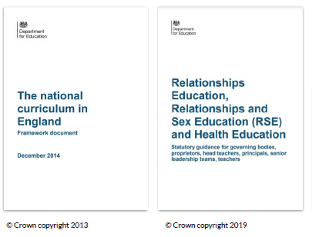
The Heart Smart scheme of work fulfils the statutory requirements for Relationships and Health Education set out by the Department for Education. It also fulfils the National Curriculum requirement to teach PSHE (‘All schools should make provision for personal, social, health and economic education) and goes beyond the statutory requirements by referring to the PSHE Association Programme of Study (recommended by the Department for Education.)
Both the My Happy Mind and Heart Smart schemes of work have categorised lessons into five key areas (shown below), which we teach on a rolling basis, due to our mixed age classes, on a three- year cycle. Each class covers each of the areas each year, making pupil’s prior and future learning clear and shows how what we are teaching fits into the children’s wider learning journey.
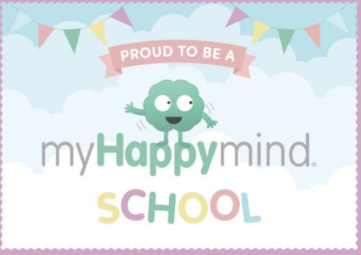
​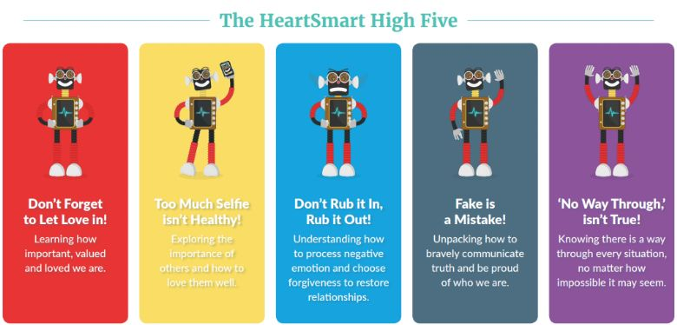​
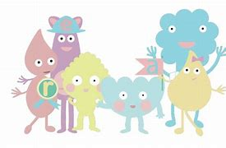
1. Meet Your Brain – Learning about how our brains work.
2. Celebrate – Understanding our character strengths and celebrating ourselves.
3. Appreciate – Developing gratitude as a habit.
4. Relate – Building positive relationships.
5. Engage – Engaging with the world.

This is our current, three-year cycle:
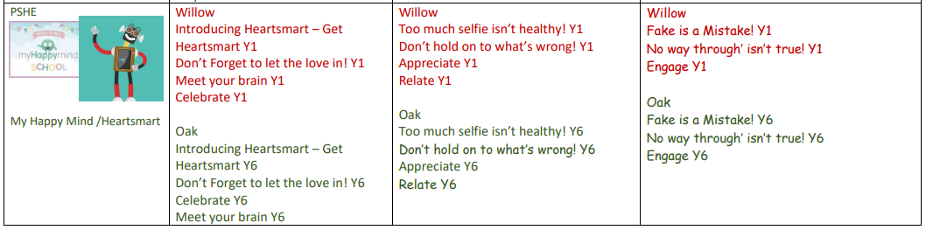
Cycle A

Cycle B

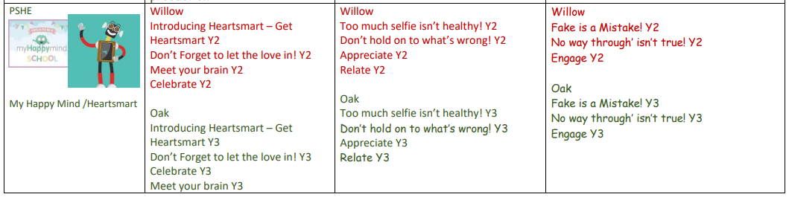
Cycle B

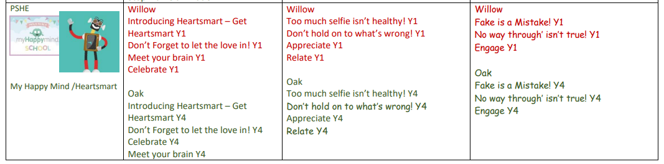
Cycle C

What about sex education?
Sex education is not compulsory in primary schools, beyond what is laid out in the National Curriculum for Science:
● Year 1: Identify, name, draw and label the basic parts of the human body and say which part of the body is associated with each sense.
● Year 2: Notice that animals, including humans, have offspring which grow into adults
● Year 5: Describe the life process of reproduction in some plants and animals; describe the changes as humans develop to old age [They should learn about the changes experienced in puberty.]
We follow the National Curriculum guidelines for Science and teach the above material within our Science curriculum offer.
RSE as part of a wider PSHE curriculum plays a very important part in fulfilling the statutory duties all schools have to meet. PSHE helps children understand the difference between safe and abusive relationships and equips them with the skills to get help if they need it. It also teaches them about the importance of a healthy lifestyle and positive mental health, about online and offline safety.
Schools have responsibilities for safeguarding and a legal duty to promote pupil well-being (Education and Inspections Act 2006 Section 38). Cleeve Prior CE Primary School’s PSHE incl. RSE Policy outlines the programme, aims and objectives and an overview of the content.
We aim to deliver high quality Personal, Social, Health Economic Education (PSHE) in which we deliver accurate, relevant and age appropriate information about relationships – one of the core strands of PSHE. This will ensure that we give our children the best possible chances to achieve their full potential and leave our school prepared for the demands of society in their future.
We aim to teach children about relationships in an engaging, meaningful and age-appropriate manner through a carefully considered spiral curriculum which considers the emotional, physical and social maturity of our children.
We believe that the education we provide should reflect both the universal needs shared by all pupils as well as the specific needs of individual pupils in school setting. As such, the Relationships’ strand of our PSHE curriculum has been carefully considered and is constantly being reviewed so that it is inclusive and meets the needs of each and every one of our children.
It is our aim to ensure that Relationships’ Education is taught consistently throughout the school, specifically focusing on teaching children the fundamental building blocks and characteristics of positive relationships, including friendships, family relationships and relationships with other children and adults. This will also include the importance of respectful relationships, online relationships and keeping themselves safe. We will provide them with the knowledge and attributes needed to support wellbeing and attainment and ultimately prepare them to become successful and happy adults. We believe that Relationships’ Education equips our children with the understanding, knowledge and skills they will need to succeed and thrive. Teaching about relationships enables our pupils to safely negotiate making new friendships, recognise potential threats to their wellbeing and develop meaningful relationships with others throughout their lives. We strive to promote equality through all aspects of our Relationships’ teaching. As such, our curriculum promotes tolerance and acceptance.
PSHE inc. RSE has clear links with other school policies aimed at promoting pupils’ spiritual, moral, social and cultural development, including the:
• Behaviour Policy
• Anti-Bullying Policy
• Staff Code of Conduct Policy
• Equality Policy
• Safeguarding and Child protection Policy
• Acceptable Use Policy
• Online Safety Policy
• Inclusion Policy
• Policy for RE
• SMSC Policy
• Special Educational Needs and Disabilities Policy
The role of the Head of School and Governing body
It is the responsibility of the Governors to ensure that as well as fulfilling their legal obligations, they make sure that:
• all pupils make progress in achieving the expected educational outcomes in regard to PSHE incl. RSE;
• PSHE is well led, effectively managed and well planned;
• the quality of PSHE provision is subject to regular and effective self-evaluation;
• teaching is delivered in ways that are accessible to all pupils with SEND;
• clear information is provided for parents on the subject content and the right to request that their child is withdrawn; and,
• the subjects are resourced, staffed and timetabled in a way that ensures that the school can fulfil its legal obligations.
The Head of School liaises with external agencies regarding the school RSHE programme and ensures that all adults who work with children on these issues are aware of the school policy, and that they work within this framework.
The Head of School monitors this policy on a regular basis and reports to governors on the effectiveness of the policy.
Monitoring and Review
The governing body monitors the PSHE incl. RSE policy on an annual basis. The Governors give serious consideration to any comments from parents about the sex education programme, and makes a record of all such comments. Governors require the Head of School to keep a written record, giving details of the content and delivery of the PSHE incl. RSE programme that is taught in our school. Governors should scrutinise materials to check they are in accordance with the school’s ethos. Parents and carers have the right to see sample materials used within the teaching of PSHE incl. RSE and can do so by making a prior appointment with a member of staff.
As My Happy Mind and Heart Smart materials are copyrighted, the school is not permitted to put teaching materials on the public facing website or provide electronic copies of materials to parents and carers at home but parents are able to come into school to view the plans.
Equalities
The Equality Act 2010 covers the way the curriculum is delivered, as schools and other education providers must ensure that issues are taught in a way that does not subject pupils to discrimination. Schools have a duty under the Equality Act to ensure that teaching is accessible to all children and young people, including those who are lesbian, gay, bisexual and transgender (LGBT).
Inclusive PSHE incl. RSE will foster good relations between pupils, tackle all types of prejudice – including homophobia – and promote understanding and respect. The Department for Education has produced advice on The Equality Act 2010 and schools (DfE, 2014b). Schools have a legal duty to promote equality (Equality Act, 2010) and to combat bullying (Education Act, 2006) (which includes homophobic, sexist, sexual and transphobic bullying) and Section 4.2 of the national curriculum (2014) states “Teachers should take account of their duties under equal opportunities legislation that covers race, disability, sex, religion or belief, sexual orientation, pregnancy and maternity, and gender reassignment.” “Schools should be alive to issues such as everyday sexism, misogyny, homophobia and gender stereotypes and take positive action to build a culture where these are not tolerated, and any occurrences are identified and tackled.
Staff have an important role to play in modelling positive behaviours. School pastoral and behaviour policies should support all pupils.” (DfE, 2019)
Withdrawal from PSHE incl. RSE lessons
Parents/carers have the right to withdraw their children from Sex Education provided at school except for those parts included in statutory National Curriculum Science and that included within Statutory Relationships and Health Education. Most RSE content taught at Cleeve Prior is through our Science Curriculum. Parents are welcome to make an appointment to see the Head of School who will explore any concerns they may have.
The teaching materials are available for parents/carers who wish to view the content covered. Parents/carers of Year 5 pupils will be informed by letter prior to starting the Science lessons with an invitation to discuss the content of the unit.
Working with parents and carers
The government guidance on Relationships, Sex Education and Health Education (DfE, 2019) emphasises the importance of schools working in partnership with parents and carers. Parents should be given every opportunity to understand the purpose and content of Relationships Education within our school.
Teaching Sensitive and Controversial Issues
Sensitive and controversial issues are certain to arise in learning from real-life experience. Teachers will be prepared to handle personal issues arising from the work, to deal sensitively with, and to follow up appropriately, disclosures made in a group or individual setting.
Issues that we address that are likely to be sensitive and controversial because they have a political, social or personal impact or deal with values and beliefs include: family lifestyles and values, physical and medical issues, financial issues, bullying and bereavement.
Teachers will take all reasonable, practical steps to ensure that, where political or controversial issues are brought to pupils’ attention, they are offered a balanced presentation of opposing views.
Teachers will adopt strategies that seek to avoid bias on their part and will teach pupils how to recognise bias and evaluate evidence. Teachers will seek to establish a classroom climate in which all pupils are free from any fear of expressing reasonable points of view that contradict those held either by their class teachers or their peers.

This policy was written in September 2024 and will be reviewed in September 2025.

