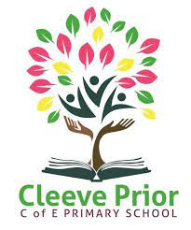

Dear Parents,

Welcome to the Summer Term in Willow Class. Our new topic is ‘Discovering Dinosaurs’. Below, are details of what we will be learning about in each subject, so that if you would like to complete further activities at home you can.
Please ensure your child continues to read to someone at home every day; practise their weekly spellings, use Numberbots or TTRS to complete their Garage heatmap and complete the weekly Mathletics homework.

English  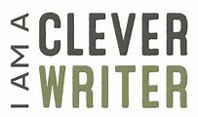 |  | We will be using a variety of different books and hooks this term, including Stone Girl, Bone Girl and Harry and the bucket of dinosaurs  The text types we will be writing are:  Recounts  Diary Entries  Character Description  Setting Description
Maths   |  | Reception  Exploring 3D shapes  20 and beyond  Manipulate, compose and decompose  Sharing and grouping  Visualise, build and map  Making connections  Year 1  Mass and Volume  Multiplication and division  Fractions  Position and direction  Place value with 100  Money  Time  Year 2  Mass, capacity and temperature  Fractions  Time  Statistics  Position and Direction  Consolidation
Science  (Mrs Laughlin)   |  | Science topic 1 will be Animals  Year 1 Classification  Year 2 Life cycles and basic needs  Science topic 2 Living things and their habitats  Y1 Living things and their habitats – our school environment  Y2 Living things and their habitats – food chains
Computing  (Mrs Millard)  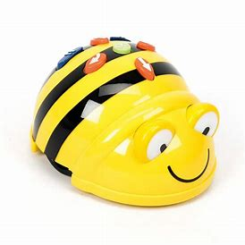 |  | Programming – Moving a Robot  Creating Media – Digital Writing  Programming – Animations  Online Safety –  Managing Online Information  Health, Well-being and Lifestyle  Privacy and Security  Copyright and Ownership
R.E.  (Mrs Laughlin) |  | What does it mean to belong to a faith community?  What makes some places sacred to believers?
History  Geography - | Discovering Dinosaurs  Mary Anning – Fossil Hunter  Map work
P.E. (Mrs Laughlin)   | First half-term Dance – Ribbon dancing / Fan dancing
Art/D.T.   | Dinosaurs: Primitive art / charcoal chalk (Art)  Mechanisms: Moving Monsters (DT)
Music  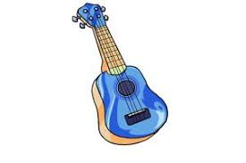 | Drums with Ms Reid on a Thursday
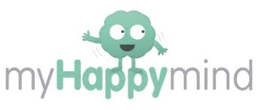  P.S.H.E.   | Heartsmart –  Don’t hold on to what’s wrong!  Fake is a mistake!  ‘No way through’ isn’t true!  My Happy Mind-  Relate  Engage

If you have any queries about any of the above, or about how you can support your child further at home, please do not hesitate to contact me.

Yours Sincerely

Mrs Norden

