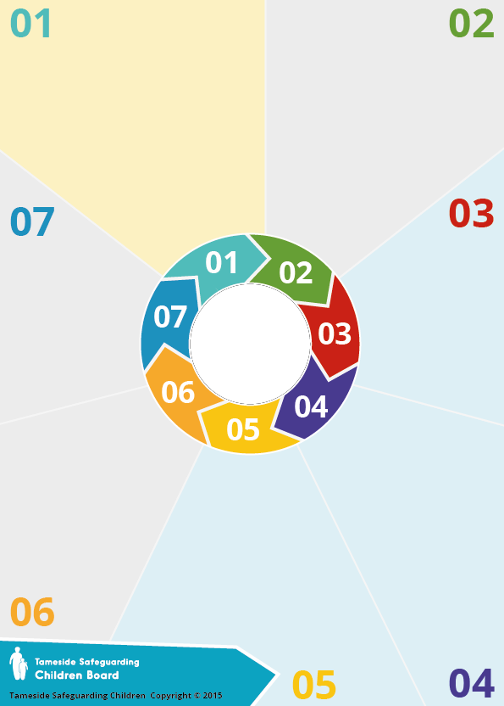
Background

'GET SAFE' is the Worcestershire name for our multi-agency support and protection for children and young people
at risk of exploitation.
Based at the Family Front Door in County Hall, the HQ of Worcestershire Children first, the team is managed as part Worcestershire’s Children’s Social Work Services but works with all the teams and services who are part of WCF. The GET SAFE Team is co-located in the Multi Agency Safeguarding Hub (MASH). This enables them to work closely with partner agencies such as West Mercia Police, Health, Education
Safeguarding, Adult Safeguarding and Youth Justice sharing
information and ensuring concerns are quickly
responded to. The GET SAFE Partnership
is committed to tackling Child
Exploitation and supporting victims
and their families who
experience this.

GET SAFE
stands for:

Gangs
Sexual Exploitation
Trafficking
Modern Day Slavery
Absent or Missing
Forced Marriage
Criminal Exploitation

GET SAFE (sharepoint.com)



Useful links
The Children’s Society: https://www.childrenssociety.org.uk/
Criminal exploitation resources for professionals
Young Minds UK:
https://www.youngminds.org.uk/
supporting young persons and their
mental health
Neighbourhood Watch https://www.ourwatch.org.uk/
Spotting the signs and supporting victims
Climb
Partnered with West Mercia Police, they provide positive activities to steer YP away from criminal activity
https://www.childrenssociety.org.uk/climb

GET SAFE

What is CSE?

Child Sexual Exploitation (CSE) is a form of child sexual abuse where an individual or a group of people takes advantage of an imbalance of power to coerce, manipulate or deceive a child (anyone under the age of 18) into sexual activity for which the child receives something they want or need in exchange.
This could be food, accommodation, drugs, alcohol, cigarettes, money, gifts, or affection. This could also be for the
financial advantage or increased
status of the perpetrator. A victim
may initially think the relationship
is consensual. Child sexual
exploitation can occur online, as well
as in person, and does not always
include physical contact.
Safe and Sound
(Document Title - You can use the Document Title) (sharepoint.com)

https://www.safeandsoundgroup.org.uk/

What does criminal

exploitation mean?

Speak to your child and tell

them what you are worried about.

Let them know they are not in

trouble and that you are worried.

If your child has missed a curfew time and
you have exhausted all avenues to locate them, consider reporting them missing to the police.

Where possible keep a record of any worrying activity as it will help find out what is happening
be aware that there may be threats against you or your family that your child is worried about from those who are exploiting your child - your child
may believe they are protecting you

What does criminal exploitation mean?

This is when children are used by people, sometimes older or in gangs or groups, for criminal activity such as carrying or selling drugs or weapons, running money, involved
in robberies or hiding things.

When children are sent by others to commit crime that is of benefit to the person,
gang or group, this is criminal exploitation
and trafficking. It is important to know
you are not alone. There are many
parents and carers in similar
situation and there are things
you can do.

Access WCF
safeguarding procedures at:
www.worcestershire.gov.uk/safeguardingchildren
If you have child protection concerns you can refer to our Children’s Social Care team at:
01905 822666 (daytime)
01905 768020 (out of office hrs emergency).
You can share information with Police anonymously to help identify risks via
CrimeStoppers UK:
0800 555 111

