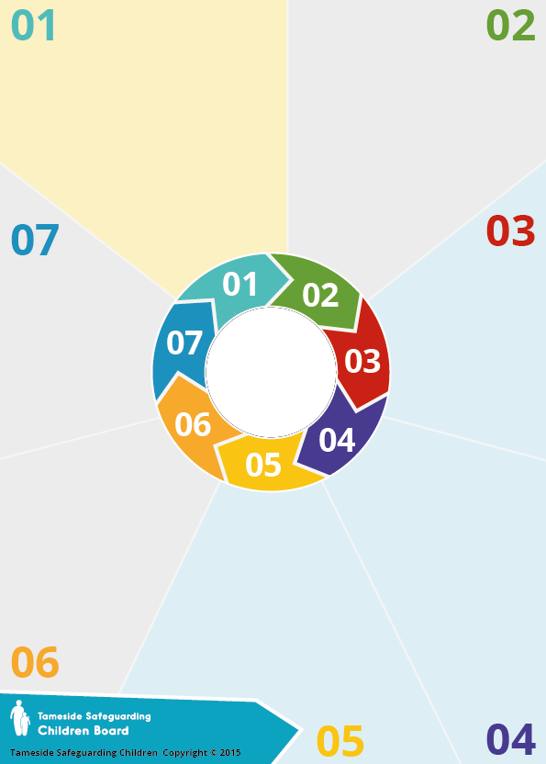

Background

Social Media has transformed the way society communicates. It brings a variety of benefits including giving a voice to those who may not previously have been heard - none more so than our Children and Young People (C&YP). However, the speed at which the online environment has evolved has also magnified existing safeguarding issues, including those associated with Mental Health & Wellbeing (MH&W).

Whilst we must remember that Social Media can be a hugely positive influence, it also undoubtedly has the potential for negative and hugely destructive influence, particularly for C&YP.

Whilst there is growing recognition, as a topic, the influence of Social Media on C&YP’s MH&W is a vast, developing and often complex area.

Technology is an integral part of modern society, especially for C&YP who are typically hugely invested in its day-to-day application.

* Adverse effects of Social Media and their indicators can be numerous, developing and may include: online addiction; anxiety; low self-esteem; online bias; isolation; oversharing; jealousy/envy/unrealistic expectations; FOMO (Fear Of Missing Out); online bullying or hate crime, depression and self-harm.
* Negative experiences online can

re-enforce and further exacerbate

pre-existing Mental Health

conditions

.

Why it matters



**Social Media**

Would I know how to appropriately respond to a MH&W concern that may include an online element?

Do my organisational polices & procedures for MH&W consider online aspects?

What online NHS tools may help young people with self-harm and

anxiety?

Do not be distracted by the technology - mental health concerns are a safeguarding issue and should not wait.

* Discussing the issue is an important step but ensure you consult your manager or safeguarding lead on preferred support routes.
* Removing access to devices could inadvertently increase anxiety and worsen issues by preventing access to support mechanisms and

networks that are valued

by the young person.

What to do

Relatedly, the selfie should ideally achieve at least 48 ‘likes’ before being considered successful. Posts on Social Media will therefore often present an ‘idealised’ view which is often at odds with the actual truth and as such, can create unrealistic expectations for others.

Different platforms have both positive and negative aspects. The highly-regarded RSPH report #StatusOfMind provides a breakdown of popular platforms and their suggested impact on MH&W

1.YouTube 2.Twitter 3.Facebook

4.Snapchat 5.Instagram

Learning

Social Media is designed to keep users engaged with the platform. As such, it demonstrates ‘*persuasive design’* – a concept whereby technology is used to influence user behaviour. The ‘*Streaks*’ feature on Snapchat is an example of how this concept is employed to significant effect and the consequent impact this can have introduces huge pressures on C&YP to maintain continual interaction. Persuasive design, alongside receiving positive reception of posts, are often highlighted as key factors encouraging ‘online addiction’. Research suggests a typical teenager will check their phone around 150 times per day on average (FOMO). A less obvious consequence of the need for continual interaction is the impact on self-esteem and anxiety. YP may feel the need to constantly message their close friends in order to maintain close friendships in real life. This is also apparent in ‘curating’ an online persona – research suggests the average number of selfies a young person takes before sharing just one is 12, with just under 50% of young people also adding a filter to ‘improve’ their appearance.

Questions to

consider

Information