# 

**Background**

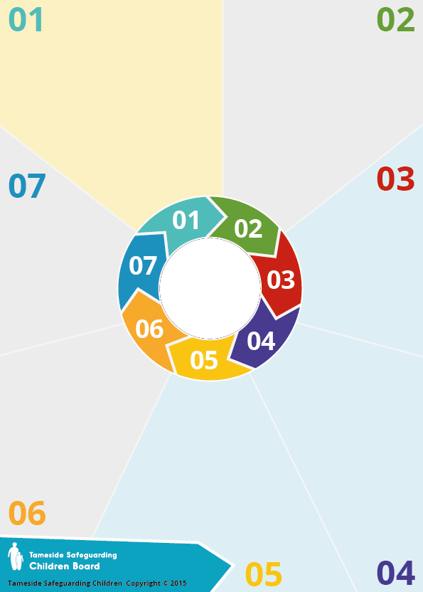

'GET SAFE' is the Worcestershire name for our multi-agency **support** and **protection** for children and young people

at risk of **exploitation.**

Based at the Family Front Door in County Hall, the HQ of Worcestershire Children first, the team is managed as part Worcestershire’s Children’s Social Work Services but works with all the teams and services who are part of WCF. The GET SAFE Team is co-located in the Multi Agency Safeguarding Hub (MASH). This enables them to work closely with partner agencies such as West Mercia Police, Health, Education

Safeguarding, Adult Safeguarding and Youth Justice sharing

information and ensuring concerns are quickly

responded to. The GET SAFE Partnership

is committed to tackling Child

Exploitation and supporting victims

and their families who

experience this.

**GET SAFE**

**stands for:**

Gangs

Sexual Exploitation

Trafficking

Modern Day Slavery

Absent or Missing

Forced Marriage

Criminal Exploitation

[GET SAFE (sharepoint.com)](https://worcestershirecc.sharepoint.com/sites/wcf/socialcare/getsafe)



## Useful links

**The Children’s Society**: <https://www.childrenssociety.org.uk/>

Criminal exploitation resources for professionals

**Young Minds UK**:

<https://www.youngminds.org.uk/>

supporting young persons and their

mental health

**Neighbourhood Watch** <https://www.ourwatch.org.uk/>

Spotting the signs and supporting victims

**Climb**

Partnered with West Mercia Police, they provide positive activities to steer YP away from criminal activity

<https://www.childrenssociety.org.uk/climb>

## What is CSE?

**Child Sexual Exploitation (CSE)** is a form of child sexual abuse where an individual or a group of people takes advantage of an imbalance of power to coerce, manipulate or deceive a child (anyone under the age of 18) into sexual activity for which the child receives something they want or need in exchange.

This could be food, accommodation, drugs, alcohol, cigarettes, money, gifts, or affection. This could also be for the

financial advantage or increased

status of the perpetrator. A victim

may initially think the relationship

is consensual. Child sexual

exploitation can occur online, as well

as in person, and does not always

include physical contact.

Safe and Sound

[(Document Title - You can use the Document Title) (sharepoint.com)](https://worcestershirecc.sharepoint.com/sites/wcf/getsafe_/Get%20safe%20documents/GET%20SAFE%20Strategy%202020.pdf#search=exploitation)

<https://www.safeandsoundgroup.org.uk/>

# What does criminal

# exploitation mean?

# Speak to your child and tell

# them what you are worried about.

# Let them know they are not in

# trouble and that you are worried.

If your child has missed a curfew time and

you have exhausted all avenues to locate them, consider reporting them missing to the police.

Where possible keep a record of any worrying activity as it will help find out what is happening

be aware that there may be threats against you or your family that your child is worried about from those who are exploiting your child - your child

may believe they are protecting you

# What does criminal exploitation mean?

This is when children are used by people, sometimes older or in gangs or groups, for criminal activity such as carrying or selling drugs or weapons, running money, involved

in robberies or hiding things.

When children are sent by others to commit crime that is of benefit to the person,

gang or group, this is criminal exploitation

and trafficking. It is important to know

you are not alone. There are many

parents and carers in similar

situation and there are things

you can do.

Access WCF

safeguarding procedures at:

[www.worcestershire.gov.uk/safeguardingchildren](http://www.worcestershire.gov.uk/safeguardingchildren)

If you have child protection concerns you can refer to our Children’s Social Care team at:

**01905 822666** (daytime)

**01905 768020** (out of office hrs emergency).

You can share information with Police anonymously to help identify risks via

CrimeStoppers UK:

**0800 555 111**